Whitepaper

Making sure that your project is on-track.

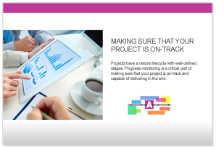Learn from the customer experiences outlined in this whitepaper.

Projects have a natural lifecycle with well-defined stages. Progress monitoring is a critical part of making sure that your project is on-track and capable of delivering in the end.

From start-up meetings to final sign-off, we have the solutions for today’s market-driven needs. Leverage your assets to the full through the combination of Alloy Plan, Alloy Meet, Alloy Track and Alloy Training